Task-1 Draw a labeled diagram of an ATX motherboard and mark at least 8 different slots and ports (such as RAM slots, PCIe slots, SATA ports, USB headers, CPU socket, power connector, etc.).

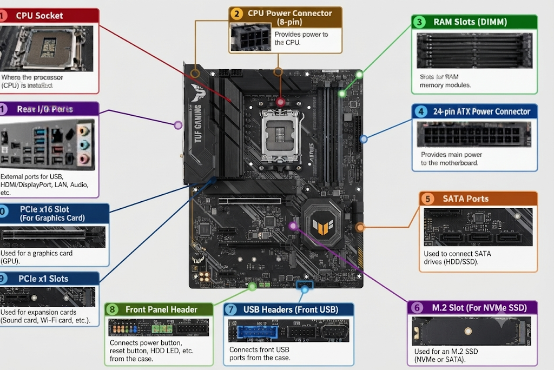

Task-2 Research and list 3 popular CPU socket types (for example: LGA1151, AM4, LGA1200) and name one compatible CPU model for each.

Here are 3 popular CPU socket types along with an example of a compatible processor model for each:

1. AMD AM4
- Platform Overview: A highly popular mainstream desktop socket from AMD that uses a Pin Grid Array (PGA) design and supports DDR4 memory.

- Compatible CPU Example: AMD Ryzen 5 5600X (Zen 3 architecture)

2. Intel LGA1700
- Platform Overview: A desktop socket used by Intel for its 12th, 13th, and 14th generation processors, adopting a Land Grid Array (LGA) design with support for both DDR4 and DDR5 memory depending on the motherboard.

- Compatible CPU Example: Intel Core i5-13600K (13th Gen Raptor Lake)

3. AMD AM5
- Platform Overview: AMD's modern desktop socket platform featuring an LGA design, native support for DDR5 memory, and compatibility with Ryzen 7000-series processors and newer.

- Compatible CPU Example: AMD Ryzen 7 7800X3D (Zen 4 architecture)

Task-3 Explain in your own words the primary functions of the CPU and the chipset on a motherboard, and describe how they work together when you open a music app like Spotify.

1. The CPU (Central Processing Unit)
Often called the brain of the computer, the CPU’s primary job is to process instructions and perform complex calculations.

- Execution: It fetches instructions from software code, decodes them, and executes them at incredible speeds.

- Logic and Math: It handles all the logical decisions and arithmetic required to run your operating system, games, and apps.

- Core Coordination: Modern CPUs feature multiple cores that can handle many tasks simultaneously, allowing your computer to multitask seamlessly.

2. The Motherboard Chipset (Platform Controller Hub)
If the CPU is the brain, the chipset is the central nervous system and traffic controller. Because the CPU cannot directly talk to every single component on the motherboard at once, the chipset manages that communication.

- Data Flow: It controls data traffic between the CPU and slower peripherals, such as USB ports, storage drives (SSDs/HDDs), audio chips, and network cards.

- I/O Management: It handles Input/Output (I/O) operations, ensuring that data moving to and from your mouse, keyboard, and hard drives reaches the CPU efficiently.

How They Work Together: Opening Spotify
When you click on the Spotify icon to start listening to music, the CPU and chipset coordinate a rapid sequence of events:

- The Click (Input & Chipset): When your mouse click registers, the signal travels through the USB port. The chipset receives this signal and immediately alerts the CPU that an action has been requested.

- Retrieving Data (Chipset & Storage): The CPU instructs the chipset to open Spotify. The chipset acts as the courier, digging into your SSD (where Spotify's program files are stored) and pulling those files into the system memory (RAM).

- Processing the Launch (CPU): Once the program data is staged in RAM, the CPU takes over. It reads the code, sets up the graphical user interface (GUI), and boots up the application processes.

- Streaming and Audio (Teamwork):

  - Network & Data: Spotify needs to connect to the internet to load your playlists. The chipset manages the network card to fetch data packets from the web.

  - Decoding & Playboard: The CPU crunches the incoming digital data, decoding the compressed audio files (like Ogg Vorbis or MP3) into sound waves.

  - Output: Finally, the processed audio data is sent through the motherboard's built-in audio controller (coordinated by the chipset) to your headphones or speakers so you can hear your music.

Task-4 Find a clear photo of a real motherboard (from the internet or your own device), and identify at least 5 different ports or slots by circling them and labeling each one.
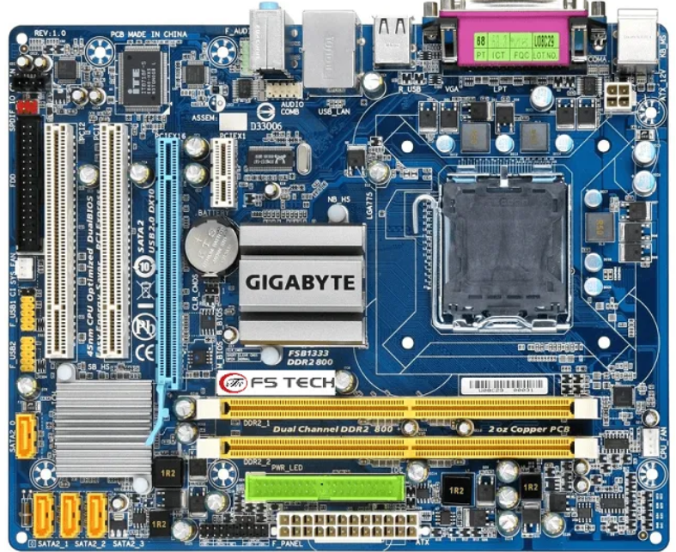

Key Ports and Slots Highlighted in the Image:
- CPU Socket (LGA 1700): Located near the center-top, this retention mechanism houses the processor (CPU) and makes direct electrical contact with its thousands of landing pads.

- RAM Slots (DIMM Slots): Positioned to the right of the CPU socket, these long vertical slots hold the system memory modules (DDR4 or DDR5 RAM).

- Power Connectors (24-Pin ATX & 8-Pin EPS): Situated along the top and right edges, these receptacles connect to power supply cables to deliver stable electrical current to the motherboard and processor.

- M.2 Slots (NVMe/Storage): Low-profile slots integrated directly onto the surface of the board designed for high-speed M.2 solid-state drives (SSDs).

- SATA Ports: Edge-facing ports used to connect traditional 2.5-inch SSDs or 3.5-inch mechanical hard drives.

- Rear I/O Ports: Clustered on the far-left edge, this panel provides external access to USB ports, audio jacks, network ports, and display outputs.

